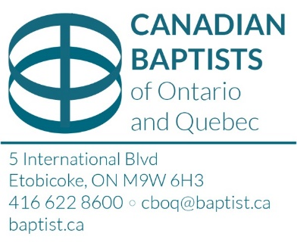
Canadian Baptists of Ontario and Quebec
Donation of Canadian Securities Advice

Section 1 (To be completed by the delivering institution)

Please be advised that the following transfer is to be made to the Canadian Baptists of Ontario and Quebec (CBOQ) Restricted Account No: 425-58316-14. We have also assigned ownership to ScotiaMcLeod. The security(ies) will be
valued as of the close of trading on the date they are received. An income tax
receipt will be issued to the donor for this amount.

Name of donor: ____________________________ Daytime phone no:

Email Address: ________________________________________________________________________

Address: _____________________________________________________________________________

Brokerage Firm: Account no:

Broker’s Name: Broker’s no: Phone:

Fax: Date of transfer:

Name of security: Where traded:

No. of shares: CUSIP no: Class of shares:

Contact:

By this signature I hereby instruct my broker to effect transfer to the CBOQ Restricted Account No. 425-58316-14.

I further instruct CBOQ to:
- Sell the shares and distribute the net cash value to: Bridle Trail Baptist Church, 10 Waterbridge Lane, Unionville, Ontario

Signature: Name: Date:

Please fax or email a copy of this form to Lanita Rozario (email: lanita.rozario@scotiawealth.com or fax: 416-865-6448), Adam Cree (email: acree@baptist.ca), and Paola Alvarez (email: palvarez@baptist.ca).

Section 2 (To be completed by ScotiaMcLeod) Contact name: Matt Horan c/o Lanita Rozario

Email: lanita.rozario@scotiawealth.com
Dealer Code: 9155 Rep Code: M88 FINS: T085 Fax: (416) 865-6448

Market value at date of receipt of notification (for tax purposes): $

Net cash value after sale: $ Date of sale:

Signature: Name: Date:

