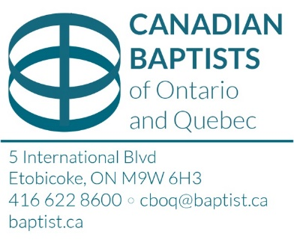
Canadian Baptists of Ontario and Quebec
Donation of Securities Form

Name of donor: ____________________________ Daytime phone no:

Email Address: ________________________________________________________________________

Address: _____________________________________________________________________________

Brokerage Firm: Account no:

Broker’s Name: Broker’s no: Phone:

Fax: Date of transfer:

Name of security: Where traded:

No. of shares: CUSIP no: Class of shares:

Contact:

The securities will be valued at the close of trading on the date they are received. An income tax receipt will be issued to the donor for this amount.

I instruct CBOQ to:

- Sell the shares and distribute the net cash value to: Bridle Trail Baptist Church, 10 Waterbridge Lane, Unionville, Ontario

By this signature I hereby instruct my broker to effect transfer to Canadian Baptists of Ontario and Quebec:
BMO InvestorLine Account: 239-17528
CUID: NTDT
FINS: T009

Signature: Name: Date:

Please submit this form to your brokerage firm to transfer your donation of securities to Canadian Baptists of Ontario and Quebec.

After the transfer is completed, please email a copy of this form to Paola Alvarez (email: palvarez@baptist.ca) and Adam Cree (email: acree@baptist.ca)

